Kubernetes by google
Reference links
https://kubernetes.io/docs/reference/kubectl/cheatsheet/
https://www.scaler.com/topics/kubernetes/
https://kube.academy/courses to learn kubernetes
here it have kubernetes codes,like autoscaling
https://github.com/microservices-demo/microservices-demo/tree/master/deploy

What is kubernetes?????????????????????????????????????????????????????????????
Kubernetes is a container management/orchestration tool, where the process of deploying, scaling containers is automated, here based on load pods/containers will be auto scaled
Kubernetes is full of objects
👉 “Kubernetes is like a manager that runs your containers across many machines.”
How to create a docker container manually – install docker, pull docker image from docker hub using docker pull, run the image using docker run <image-name>

👉 A Kubernetes cluster = group of machines working together to run containers  on the kub cluster , the containers will be created  It has 2 main parts:  1️⃣ Control Plane (Master)  👉 Brain of the system  - API Server  - Scheduler  - Controller Manager  2️⃣ Worker Nodes  👉 Actual machines where your app runs  - Run containers (inside Pods) | 🧠 Structure  Cluster  ├── Control Plane (Master)  └── Worker Nodes (Node1, Node2, Node3)  ├── Pod → Container (Spring Boot app)  ├── Pod → Container (Another service)  📦 What is a Pod?  👉 Smallest unit in Kubernetes  - Usually contains 1 container

2 containers can communicate with each other
- Why kubernetes and advantages
- Image creation with source code --portability since we are creating an image with code+req depe, our app will consistently run same in all env
consistency- the code works same in all environments bec of configuration
- scalability containers can be easily scaled up and down
- isolation apps run independently without interfering each other – a container is nothing but some isolated space inside a hard disk, so when u r running many containers
all containers may be present in same hard disk but they are fully isolated with each other
- light weight-resource efficiency all the docker containers share the same host OS making them more light weight when compared to vm
- Dynamic auto scaling ,ex:- if ur appln cpu is 90% utilized with kubernetes u can create more instances automatically , based on the load we can scale up the number of instances, if cpu utilization is less then we can automatically scale down this is possible with an object called – HorizontalPodAutoscaler and pods will be deleted if nodes are not there, this is called auto scale down,

- Lets say we created a container and in production if it dies? What we have to do, we should again start it, but Here in kubernetes we have objects like replicaset which will ensure always 3 or n instances are always running, even if u delete 1 replica also, always it will ensures desired 3-n replicas are always present. even if u delete also, automatically pod objects will be created dynamically
- Horizontal scaling, if load increased, then replicas will be increased automatically Here ur application will be mostly available,

Image, container both are docker inspectable objects
Network is also a docker object—which is inspectable
docker inspect <container-name/id>

2)kub architecture
In kub cluster, we have a below components called
In real time, every environment will have separate cluster
Ex:- dev environment cluster is separate and prod env cluster is separate,
If u want to interact with kube cluster, then we have to use “kubectl.exe”
1)control plane-which doesn’t carry any load, hence it wont have any container,hence docker also is absent
2) node-usually means, 1 computer /1 virtual machine
Every node and every pod will be having an ip address
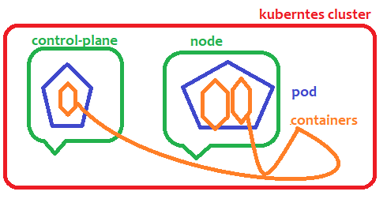
Node – node is nothing but a physical computer or virtual machine
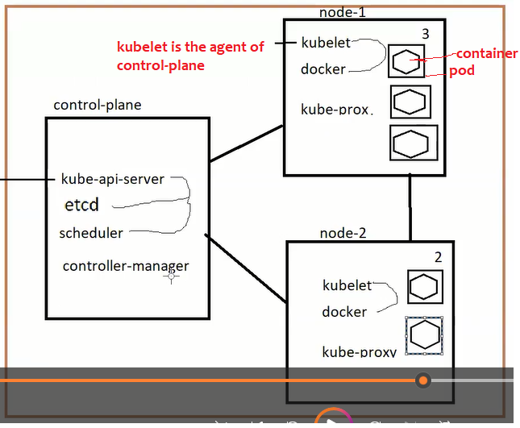

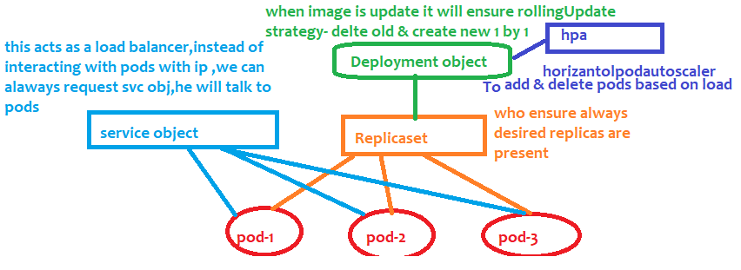

What Is pod
Pod is the way to collectively deploy 2 containers.
Therefore if 2 apps are tightly dependent, instead of deploying them as separate containers in separate vms
Better deploy them in same pod , always that single pod reside in single node,pod is a packaged,
Every node in a cluster will have some ip address and
Every pod inside a node will have some ip address
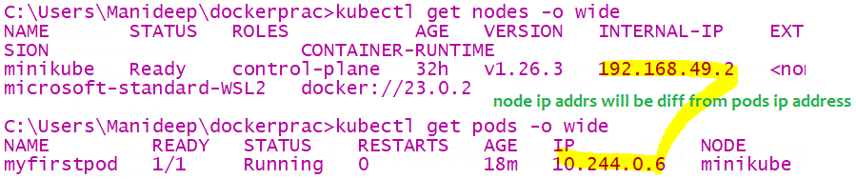

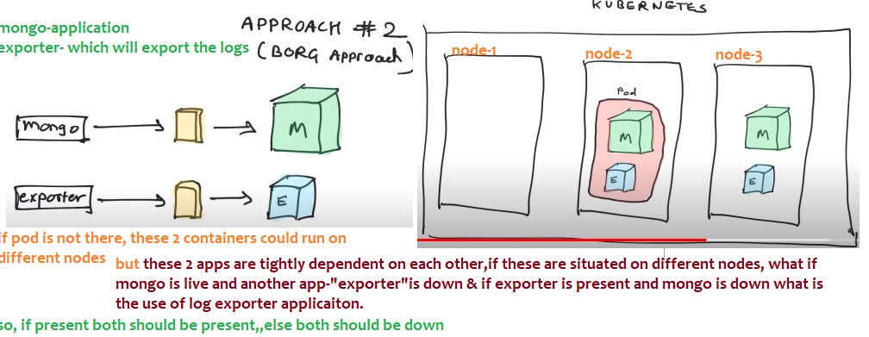
U can delete the entire pod or u can up the entire pod-
POD means just an abstract layer where containers will reside
Pod is a smallest deployable unit, in kub we can deploy only till pod, we cant directly start a container
1 node can have many pods,it is a shell around a container
1 pod can have 1 or more containers,which could be tightly dependent
Kub suggests, even if 1 container is there run that in a pod,
Lets say there are 2 images we created 2 containers for these 2 applications, these 2 are tightly dependent with each other

1) Components of control-plane
This control plane component –similar to master node,but it doesn’t carry any load ,it doesn’t have any containers
since it is not going to have containers ,control plane component doesn’t have docker installed ,
it doesn’t have any pods, and

1)kube-api-server :- this will receive all the incoming commands and it will validate all those commands
And it will send those validated commands to etcd
2)etcd:- it a database, all the state/information about entire cluster will be stored here,
like how many nodes,how many replicas,how many pods are there
in unix “etc” is a folder to store the configuration data for single system,here d means distributed,which stores the configuration for distributed systems
3)The Scheduler :- which schedules your apps (assigns a worker node to each deployable component of your application)
4)The Controller Manager:- (replica manager/node manages)
Its job is to ensure desired number of replicas and nodes(Virtual machines) are running
which performs cluster-level functions, such as replicating components, keeping track of worker nodes, handling node failures, and so on

THE NODES
The worker nodes are the machines that run your containerized applications. The task of running, monitoring, and providing services to your applications is done by the following components:
Docker, rkt, or another container runtime, which runs your containers
The Kubelet, it is the agent of control-plane node, which talks to the API server and manages containers on its node
Kubelet will talk to docker container and it will create the containers inside a pod
The Kubernetes Service Proxy (kube-proxy), it is to assign the ip-addresses, which load-balances network traffic between application components
In AWS- we have EKS-called managed cluster- Elastic kubernetes service-here entire kubernetes cluster is ready
Cluster with-control plane and kubernetes node-where those are preinstalled with docker

Important points
A Pod is a Kubernetes wrapper around one or more containers, 1 pod can contain many containers
A pod spec can store env variables also in key –value form
Use environment variables for individual configuration values. Use a volume when the application expects configuration as files or when you want Kubernetes to project multiple config files.

Notes
1. Pod → Container relationship  A Pod is a Kubernetes wrapper around one or more containers. If 2 containers cant live without each other then place them both in a single pod instead of keeping them in sep pods  Usually:  Pod  │  ├── Container 1 → Spring Boot  └── Container 2 → Sidecar  Kubernetes schedules the Pod onto a Node, and the containers run inside that Pod. | Pod  │  ├── Java container  │  ├── Sidecar container  │  └── emptyDir  │  ├── file1.tmp  ├── processed.json  └── cache/

Kubernetes commands

1) Kub cluster commands

Kubectl == kube controller is a CLI tool for kubernetes

Get cluster info
kubectl cluster-info

To get nodes & ips
Node is nothing but a separate machine, where kubernetes and docker are installed
kubectl get nodes
if u want the ipaddress of all the nodes – “kubectl get nodes –o wide”
or if u type “minikube ip” u will get the ip address of that node
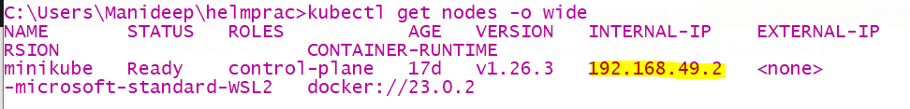

Minikube
In local, we will install a software called minikube(where docker software is pre-requisite ), minikube will give us
The single node cluster,
Kubernetes-cluster of nodes
Minikube- a cluster with single node
In production –managed solutions are
- amazon EKS-Elastic kubernetes service
- GKE- Google cloud kubernetes engine
- On prime data centre- means cluster is created and managed by our own company
After installing check whether kubernetes installed or not using “kubectl version”

Basic commands
- kubectl api-versions
//to see all the versions like v1…
- how to come back from a container
suppose if u typed “kubectl exec –it <pod-name> -- bash”, then u will inside that container, then if u want to come back
just type Ctrl+PQ
- Executing yaml file
Kubectl means- kubernetes controller
We are going to interact with kubernetes clusters component called “control-plane”
Lets say if the file “myapp.yaml” file contains pod create script,If u type “kubectl create”-it will create the pod
If u type “kubectl delete” it will delete the pod
If u are creating objects then use create command | kubectl create –f ./<filename.YAML>  kubectl create –f ./myapp..yml
To apply all changes | kubectl apply –f ./myapp.yaml
To delte the objects | kubectl delete –f ./myapp.yaml

If u have multiple files in current directory, and If u want to execute all at once then use “kubectl apply –f .”
Here dot means current directory

C:\Users\Manideep\dockerprac>kubectl apply -f ./createredispod.yaml
pod/redis created
here yaml file is executed and pod called redis is created

for example if pod creation script is present in myapp.yaml file, then if pod is not there at all then we should use create command
if pod is already present,if u are making any changes the use apply command
- CRUD -pods-Create,Delete pod

Create a pod | kubectl run manipod --image=nginx  this will create that pod with that container  EX:- kubectl run kubepod --image=bibinwilson/docker-kubectl:latest  This bibinwilson is a special image where kubectl software Is already installed
Get pods | kubectl get pods  to see the pod name  //To get pods from another namespace  kubectl get pods -n <namespace name>  kubectl get pods -n charan
Get pods from all namespace or another namespace  //Get pods from different namespace being in current namespace  kubectl get pods -n <namespace-name>  ex:-  kubectl get pods -n kube-system  kubectl get pods -n maninamespace | kubectl get pods –A  or  kubectl get pods --all-namespaces
Get pods with more info like ip address-if u want to know which pod is on which node along with ip addresses then use –o wide | kubectl get pods –o wide
Describe a pod- most famous one-  To get pod information like – 1) how many containers it have and all 2) what are the names of all containers…and 3)what is the pod ip address (both node and pod will have ip address)  4) to know who is controlling this pod-means either replicaset/ replication controller  5)to know all the labels of a pod | kubectl describe pod <pod-name>  ex:-  kubectl describe pod d1-depl-obj-name-7877f6d747-96plb
See the source code of pod in YAML format  Here –o means output | Kubectl get pod <pod-name> -o yaml  Ex:-  kubectl get pod d1-depl-obj-name-7877f6d747-96plb -o yaml
Go inside a pod of a container | //when u have only single container try this  kubectl exec –it <podname> -- bash  kubectl exec -it charanpod – bash  kubectl exec -it d1-depl-obj-name-7877f6d747 hzd5z -- bash  //means execute this command inside a running container and connect my terminal to the input stream
Delete a pod | kubectl delete pod <pod-name>
Most useful  Edit a pod- if u want to update the image version or update the labels/scale the replicas we should edit the pod | kubectl edit pod <pod-name>
To see who Is controlling this pod –I mean is  - Replicaset controlling the pod or  - ReplicationController controlling the pod | kubectl describe pod <pod-name>  ex:-  kubectl describe pod d1-depl-obj-name-7877f6d747-96plb  if u describe u should see value for field “controlled-By”
Watching pods -If u want to see pods creation and deletion dynamically | kubectl get pods --watch
How to see the logs of a pod | kubectl logs <pod-name> -c //to show container name  kubectl logs <podname> –c <containername>  //if there is no container ,u can ignore –c flag  //if u have only a single container  kubectl logs <pod name>  kubectl logs charanpod
How to see metrics like cpu utilization,metrics | kubectl top pods

Here If u observe, if u describe the pod there is a field called “controlled by”: “replicaset/…” means here
This pod is getting controlled by replicaset
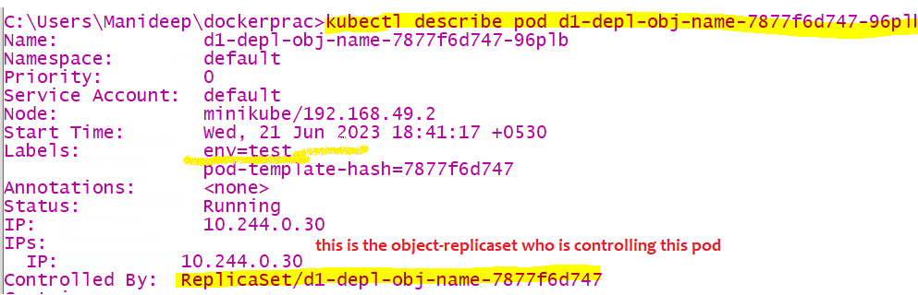

- Create a pod
Pod can be created in 2 ways
- Using kubernetes run command (deprecated)
The below command will directly create a pod p1 & run this image inside a container
C:\Users\Manideep\dockerprac>kubectl run p1 --image=nginx
pod/p1 created
- Using declarative approach-file
Write all the commands in a file and execute using
kubectl apply -f ./createredispod.yaml

apiVersion: v1
kind: Pod
metadata:
name: myfirstpod
spec:
containers:
- name: nginc1
image: nginx:latest

Using run command (deprecated)
C:\Users\Manideep\dockerprac>kubectl run p1 --image=nginx
pod/p1 created
##here u used “p1” hence a pod with name p1 is created
C:\Users\Manideep\dockerprac>kubectl get po
NAME READY STATUS RESTARTS AGE
myfirstpod 1/1 Running 0 42m
nginx 1/1 Running 0 81s
p1 0/1 ContainerCreating 0 3s

- If u want to get all pods inside a particular namespace
kubectl get pods –n <namespace name>
- To get all the pods inside default namespace
EX:- kubectl get pods -n default
kubectl get pods
means it will try to fetch those pods in default namespace
- To get pods with more information like ip address or u can describe the pod
here output of pods will be printed in wide, means more output will be printed
kubectl get pods –o wide
- Watching a pod
kubectl get pods --watch
- Describe a pod
kubectl describe pod <pod-name>
kubectl describe pod redis
Lets say if u want to know how many containers are running inside that pod then u have to describe that pod
If u describe u will get all the ip addresses of nodes and pod
Like u will get all the container names inside a pod, image id everything about that pod
There Is a difference between describing a pod and reading a pod
- Read a pod-getting the live configuration of that pod
This will get the source code of the yaml file with which it was created,
To get more information of the pod in yaml file(output of the yaml file)
kubectl get pod <pod name> -o yaml
ex:- kubectl get pod redis -o yaml

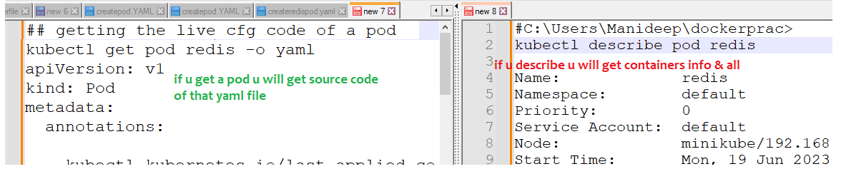

- EDIT a pod-once u edit and editor will be opened and to save changes just close that file
Now if u edit – u will get live configuration of that pod
kubectl edit pod <pod-name>
- Deleting a pod
kubectl delete pod <podname>
kubectl delete pod myfirstpod
Deleting objects/pod using created file
kubectl delete –f ./pod.YAML
means with which file this pod is created , with that file we should use delete command
here all the kub objects (pod,namespace,replicaset) mentioned in this file will be deleted

Go inside a container
- Go inside a container of a pod
Make sure here the pod must be running
kubectl exec –it <pod name> -c <container-name> bash
//u can use with or without – double hyphen
kubectl exec -it d1-depl-obj-name-7877f6d747-hzd5z sh
kubectl exec -it d1-depl-obj-name-7877f6d747-hzd5z – sh
kubectl exec -it d1-depl-obj-name-7877f6d747-hzd5z -- bash

//use either bash or sh, “sh” must be mandatorily available
kubectl exec –it <pod name> -c <container-name> sh

//to exit from a container type “ctrl+PQ”
if there is only 1 container in ur pod no need to use –c flag
kubectl exec -it myfirstpod sh
Since my pod have only 1 container, I didn’t mentioned –c flag
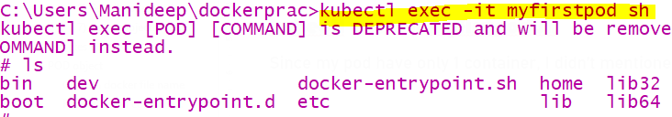
- Describe a pod –to see cont name
kubectl describe pod <pod-name>
ex:- kubectl describe pod myfirstpod
if u describe the pod u will get container name,and image with which it was created
also of all containers running inside that pod
u can describe any kubernetes object, u can describe a pod,namespace,replicaset any kubernetes object

- Get all containers in a pod
Just describe the pod , u will get the list of containers present inside that pod
kubectl describe pod <pod-name>
- CRUD nodes
A separate linux machine is called a node, in AWS we will create a separate linux machine called as node
Every node and every pod will be having an different ipaddress
Get all nodes | kubectl get nodes
Get all nodes with more information-means output in wider format | kubectl get nodes –o wide  //here u will get all nodes ip address
Describe a node to get info like- ipaddress,labels of that node | kubectl describe node <node-name>  kubectl describe node minikube
Labelling a node | Kubectl label node <node name> key=value
Show all the labels of a node | - Using describe command  - Using kubectl
Deleting the label of a node
Remember node is nothing but one virtual machine where docker is installed,
master node doesn’t carry load , so docker wont be installed in the control-plane node

- Get all nodes,pods,services everything
kubectl get all
this will get all objects present inside current namespace
kubectl get all -A
this will get all objects present inside all namespaces

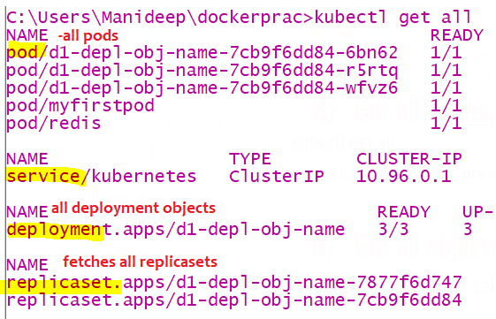
- Get all objects inside that namespace
To fetch all kubernetes objects in particular namespace, when u are in namespace1, u can get all objects present in another namespace
Here u will get all obj like – pods, replicaset, deployment, service objects, config map, secret, ingress related objects
kubectl get all –n <namespace name>
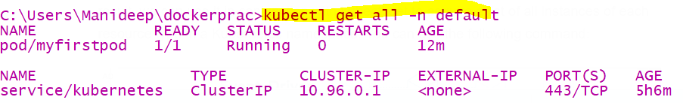
- Extract yaml file from running pod
This will not create any pod, it will just generate an yaml file with content, so that if u execute it pod/..will be created
kubectl run podhyd-redis –-image=redis –-dry-run=client –o yaml >pod.yaml
this will create a new pod with name “podhyd-redis”
kubectl run nginx --image=nginx --dry-run=client -o yaml > pod.yaml
# Generate spec for running pod nginx and write it into a file called pod.yaml
ex:-
C:\Users\Manideep\dockerprac>kubectl run redis --image=redis --dry-run=client -o yaml >createredispod.yaml
- Update image in running pod
- If u have YAML source file and edit the image name and run “kubectl apply –f ./filename”, if this file is not
Available with u then follow below , all options will work
- Just “kubectl edit pod <pod-name >” --then u will get editor ,update the image name,if u update like this
Only that particular pod will be recreated with new image and new container
- If u are using replicaset edit as “kubectl edit rs <replicaset name> ” update the image name,
- If u are using deployment object edit with “kubectl edit deployment <deployment-name> ” update the image name,- u have to edit the image name present In this hierarchy “spec-template—spec-containers-image”
Now if u update the image name in deployment object , all the nodes under that replicaset will be destroyed and recreated with latest image
- kubectl image <type of obj>/obj-name <container-name>=<new image name>
//we can update image name in pod/deployment object ..anything
// 1pod can have 2-3 containers, so its asking container name also
Ex:- kubectl set image deployment/deplobj stephencontaineroo=stephengrider/multi-worker

Kubernetes objects
Example objects:- pod,development,replicaset,replicationcontroller,service,horizantalpod,autoscaler
Api versions- https://blog.knoldus.com/what-is-apiversion-in-kubernetes-part-1/
Every kubernetes object belong to some or another api group
Ex:- replicaset belongs to “v1” group deployment obj belongs to “apps” api group
If u want to see all in built objects and their api versions and their shortcut names,then below is command
kubectl api-resources
Kind | apiversion | apiVersion means like package, means that object is present in this package, all objects present only in some package like v1 or apps/v1
Pod | v1 | Pod contains 1-n dependent containers
ReplicaSet | apps/v1 | This obj ensure always desired pods are present or not
Deployment | apps/v1 | This obj controls replicaset
Service | v1 | U talk to service object,it will talk to pods
HorizontalPodAutoscaler | autoscaling/v1 | For autoscale pods up & down
ComponentStatus | v1
Namespace | v1
Node | v1
PersistentVolumeClaim | v1
PodTemplate | v1
ReplicationController | v1
ResourceQuota | v1
Secret | v1
ServiceAccount | v1
ControllerRevision | apps/v1
StatefulSet | apps/v1
CronJob | batch/v1beta1
DaemonSet | apps/v1  extensions/v1beta1
Role
RoleBinding
ServiceAccount

Tips while writing objects
- Always the below line must start with 2 spaces right of above line
- In kubernetes one object is linked/can pick other objects only with the labels
- Metadata is nothing but data about data
apiVersion: v1
kind: Pod
metadata:
#it says name of this object either pod /deployment..
name: charanpod
#namespace tells in which namespace this object is going to reside
namespace: charan
labels:
#label can be anything it is a selector ,other objects will pick /select this object based on the label
score: low

Image with kubectl installed
Image name where kubectl is already installed
docker pull bibinwilson/docker-kubectl:latest

Yaml file syntaxes
List always starts with “- “ dash space
Example:
- tabitha:
#inner elements of a list starts with double space
name: Tabitha Bitumen
job: Developer
skills:
- lisp
- fortran
- erlang

Kub obj relations

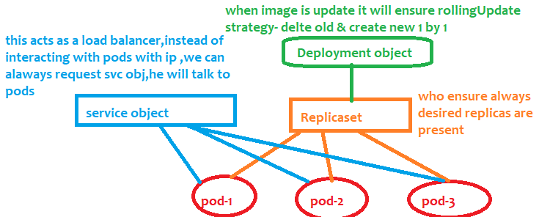

Container
A container is nothing but some isolated space inside a hard disk where all the software’s can be installed to run a specific app (app like sdp/ coreiq/ any java app) software’s like java, .net,

POD object
A pod spec can store env variables also in key –value form
Use environment variables for individual configuration values. Use a volume when the application expects configuration as files or when you want Kubernetes to project multiple config files.
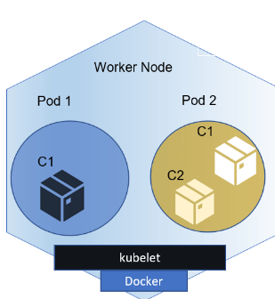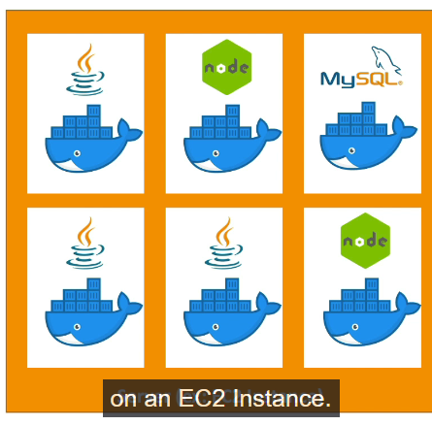 | 1 pod can have multiple docker containers  Each pod will have an ip address  So where is our application then??  As pod can have 1 or 2 containers – inside a pod inside a container (which is nothing but some isolated space in hard disk- inside that space java will be installed and our app will run there )  so here in this image , we can see same OS we can even install java multiple times, and all softwares are isolated from each other as they are in separate docker containers

Pod is also a namespace scoped object, every pod contains a 1 or many dependent containers,
Our code runs in that pod only, we can’t deploy containers directly like in docker, pod is the smallest deployable unit,
Every pod will have separate ip address and a pod is ephermal means short lived & every pod should be attached with some label to identify
The problem with object pod is –u cant replicate it, we don’t have the option to replicate the pod object
Replicas is only with respect to pod, not with respect to containers ,
Example of pod creation script,to create a pod with mentioning limited resources
If the pod is taking more cpu than mentioned, then pod will get deleted and recreated
1 pod can have more than 1 containers, if ur apps are tightly dependent create all those apps in 1 pod

apiVersion: v1
kind: Pod
metadata:
name: myfirstpod
## this is the name of the pod and it will create the pod with some labels also
spec:
containers:
- name: nginc1
image: nginx:latest

Note if that app/image here (tomcat) runs on 8080, the same port number u should mention in “container port, “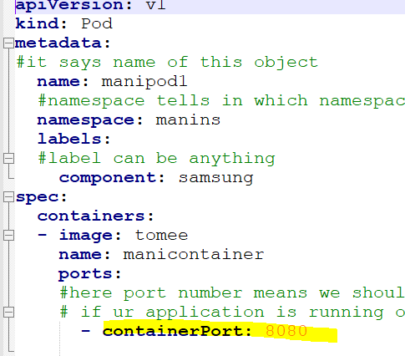

We can specify how much of memory,cpu,ram our pod can consume at max

2 containers in same pod
2 containers in same means 2 applications in same laptop/same os, those 2 apps can communicate using localhost.
If 2 containers cant live without one like child and mother then they will sit in same pod, those are tightly dependent containers,like ui and backend, if backend is waste without ui then those are tightly dependent on each other, only then put
Both containers in same pod, if they are not soo dependent then run as separate pods

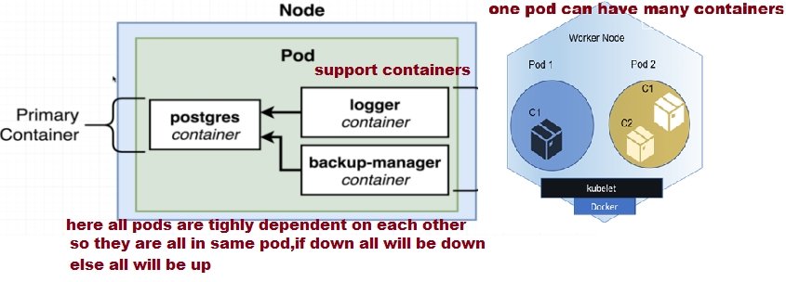

ReplicationController Object
ReplicationController Object ensures that always desired number of replicas/pods are present, even if u delete one replica among 3 desired replicas, immediately new one will be created
The only difference between pod and replication controller is ,
if u use pod object, u cant replicate, whereas when u replication controller we can create the replicas of a pod,
Remember pods are controlled by ReplicationController object
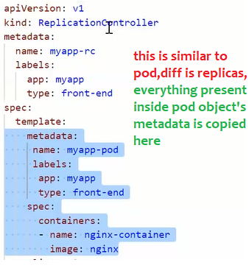

ReplicaSet object
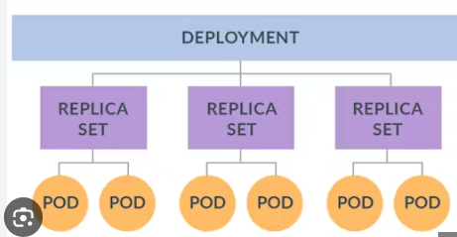
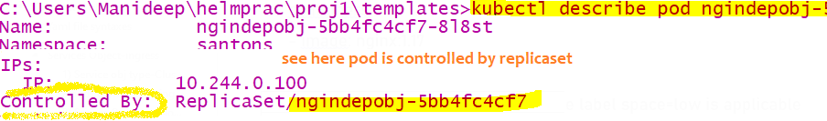

This Replicaset is a wrapper around group of pods/replicas, this is also to create replicas of a pod To ensure always desired number of pods are always there,
Remember pods are controlled by ReplicationController object or Replicaset object, & Replicaset object is controlled by
Deployment object
This object is also same as object “ReplicationController” will also ensure desired number of pods are present
# replicaset obj always ensures 3 replicas of pod are there and it will pick the pods based on the label of the pod

# this is the real object who will control the pods directly, so to control the pods it should know which pod to pick right, this replicaset will pick based on the pod label ,here we should mention which pod to pick using pod selector
Labelling a pod
template:
metadata:
#here these are the labels which will be given to each pod
labels:
space: low
spec:
containers:
- image: nginx:1.17
name: bb
here for all the nginx contianers /pod the label space=low is applicable

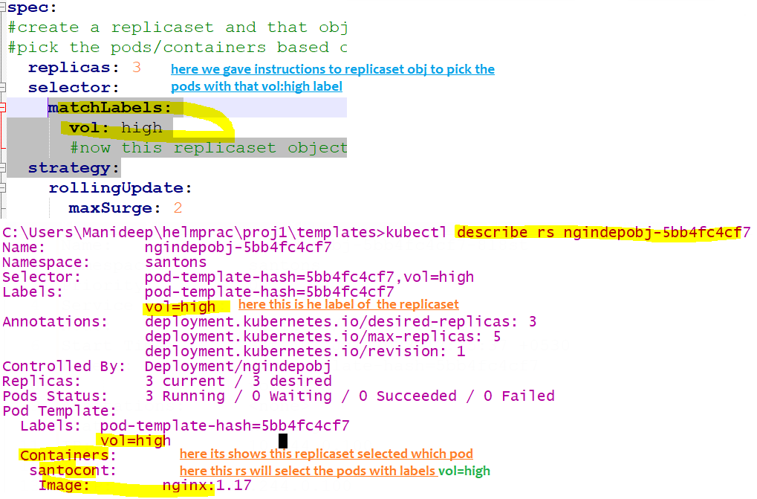

kubectl get rs  kubectl get replicasets | To get all replicaset objects type below
Kubectl describe rs <replicaset –name > | To see all label of that replicaset  And to check what is the selector ,I mean which labelled pods it will pick…u can see all this information 2) to see who is controlling this replicaset-generally replicasets will be controlled by Deployment objects
To delete a replica set | kubectl delete replicaset <replicaset-name>
Scale up or down a replicaset | kubectl scale rs <replicaset-name> --replicas=5
If u want to see who is controlling the pod  “kubectl describe pod <pod-name> ”,  If u want to see who is controlling the replicaset ,  Generally replicaset will be controlled by deployment object | Kubectl describe replicaset <replicaset -name>  There is a field called “controlled-by” :”

The difference between “ReplicationController” and “ReplicaSet” is the object ”ReplicaSet” object will have an additional
Selector to select the existing running pod
Note:-as replicaset manages pods,if we mention replicaset as 3,if any pod got deleted, it will be created automatically
If u want to delete all the pods, 1st u should delete the parent-ReplicaSet/ReplicationController object who is controlling that
Here pods are controlled by parent ReplicaSet, so if u want to delete all pods then we should delete this replicaset first
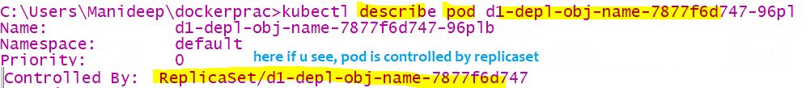
If u want to delete all nodes under replicasset-u cant pod by pod because it will always ensure 3/5/desired number of replicas are present.
Solution:-if u want to delete all nodes, better delete the replicaset first then only all pods will get deleted

Pod name | replicas
Pen ( pod selector:oldStock) | Current replicas-3
Pencil (pod selector:oldStock)  Whereas if we mention desired replicas as 5-  Diff pod with same selector (oldStock) already exists ,  hence eventhough u gave desired replicas as 5,it will create only 2 replicas,because 3 existing replicas as already present with same selector | Current replicas-0  After exec,  New replicas will be 2 because same selector 3 already exists ,so only 2 will be newly created

if we mention replicas as 3 with pod selector (stock: fresh)if an another pod is already running with same name
It will consider that criteria, Now this pod will have only 2 replicas

Deployment object
Deployment is an object which is namespace scoped,means this object can present across all the nodes
The main advantage of Deployment object is , when this object is created when that pod is running we can update the image dynamically, so slowly 1 pod will be deleted and new pod will be created, again 1 new pod will be created and 1 old pod will be deleted, so there is no downtime using the concept of rolling update,incase of other objects all old pods will be deleted first and new pods will be created with old objects we have downtime,in this Deployment object we don’t have that downtime
Deployment object is the parent object which controls the replicaset and replicaset object controls the pod object
Real time use case
- Flipkart during sale days, once sale is iver sharp 12 pm, all offers will be closed and they will show us the normal page,
How it is happening (without complete server down ) , they might be using Kubernetes deployment object, they would have entered and edited deployment object source code and change with the old image name, slowly pod by pod by it will delete old pod with old image, it will use deployment object Rolling strategy, 1 old pod with old image will be deleted and a new pod with new image will be created among 10-15 pods, slowly old and new will happen without donwitm
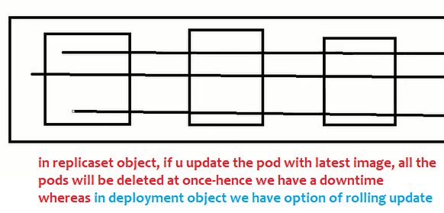

To get deployment object names | kubectl get deployment
Most useful  If u want to update image name-2 options –edit deployment object or 2) edit pod  if u are trying to edit pod, u have to edit the image name in all replicas, means edit all replicas, 2) if u Edit the deployment object, u no need to edit each and every pod, because dep is the parent object , so all replicas (are childs )image name will be updated in all pods automatically and all pods will be recreated | kubectl edit deployment <deployment object name>  kubectl edit deployment d1-depl-obj-name  ## To update the image name/update replicas count -U will get the script/deployment object script/source code in new editor, So that u can edit image name
kubectl describe deployment <deployment-name>  kubectl describe deployment d1-depl-obj-name | When u describe u will see all the labels of deployment  How many replicas, what is the image and pod selectors..and deployment strategy=rolling update/ recreate everything and  And to check what is the selector
kubectl delete deployment <>
kubectl get deployments
To get all the deployment object names
Get current source code of deployment object in yaml –now we wil get source code or yaml file with which that deployment object is created  Or even if u edit the pod also, u will be able to see the source code use “kubectl edit pod podname” | kubectl get deployment <your deployment object name> -o yaml  kubectl get deployment d1-depl-obj-name -o yaml
Scale the replicas of a deployment-to scale up or scale down | kubectl scale deployment <deployment> --replicas =5  kubectl scale deployment d1-depl-obj-name --replicas=8
Rollout the deployment to older image version | kubectl rollout undo deployment/<your deployment object name>  kubectl rollout undo deployment/d1-depl-obj-name

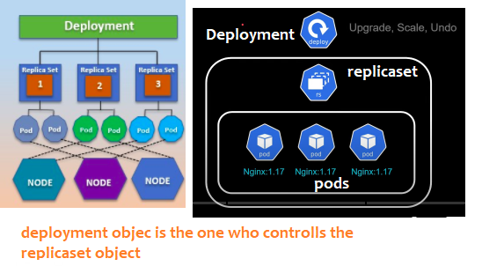
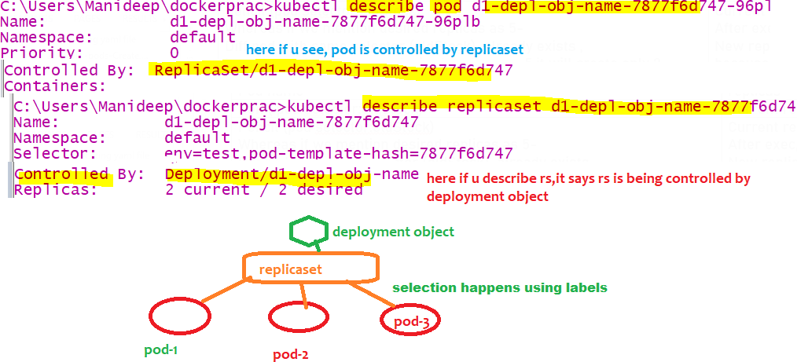

How it is working internally
Here replicaset object links/selects pod based on the label of the pod only
similarly deployment object selects replicaset object based on the label of rs object.
Like a Pod wraps around container and containers,
Replicaset object wraps around group of pods-means replicaset will manage the pods
Deployment object is a wrapper which wraps around a replicaset object,it manages the replicaset,
Replicaset which inturn manages the pods
Deplyment object restores replicaset (means if replicaset got delete,deployment obj will create it)
Replicaset restores pod(means of any pod under that matched label replicaset got deleted,rs will create pod)
If Higher level deployment object is created then all lower level objects –replicasets,pods are created automatically
The main advantage is when the replicaset is running when u update the image version in YAML file,
Deployment provides declarative updates for pods it will change the actual state to desired state in controlled rate
Note:-
Every object should have a label, else it will be difficult for wrapper /up level object to pick
eX:- here deployment object is a wrapper around replicaset object, deployment object pick/manage the object with the
specified selector
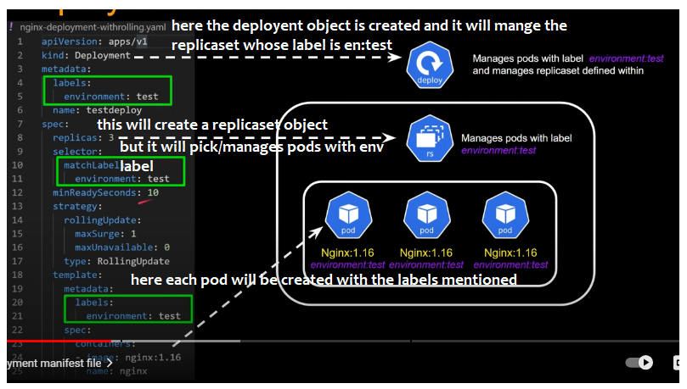
Note:label is very very mandatory to identify /manage the objects
Here parent object Deployment manages the child object replicaset only based on the label environment:test
If label is not there, deployment obje I think it cant select pods/vms try this. By updating a nginx version and check

Tips while writing deployment object
1) All the container creation logic (metadata,spec) is inside spec ,template in yaml file
2) We will have only labels plural, not singular label
3) if u want to label that us should use keyword “label”, if u are selecting some label , then u should use “matchLabels”
Commands
kubectl apply -f ./createNginxDeploymentObj.YAML
kubectl get deployments
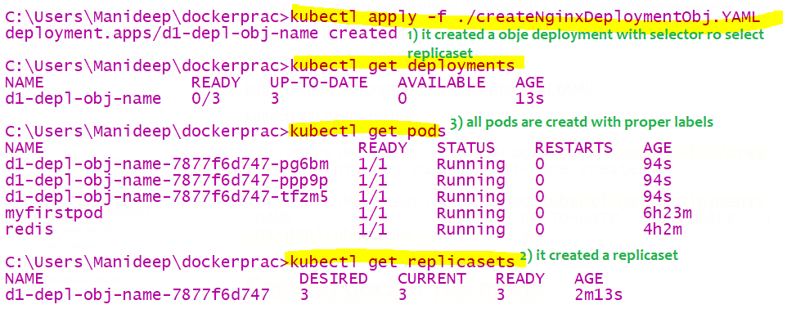

What is the use of deployment object:- when container is running we can update the image name
Earlier image name was1.16 now we update the image name to 1.17,pods Auto destroyed and newly created
The beauty with this is no downtime, all existing pods are not deleted at once, whereas in case of other objects
Like “ReplicaSet”,”ReplicationController” all pods will be deleted first and will be created everything newly with downtime

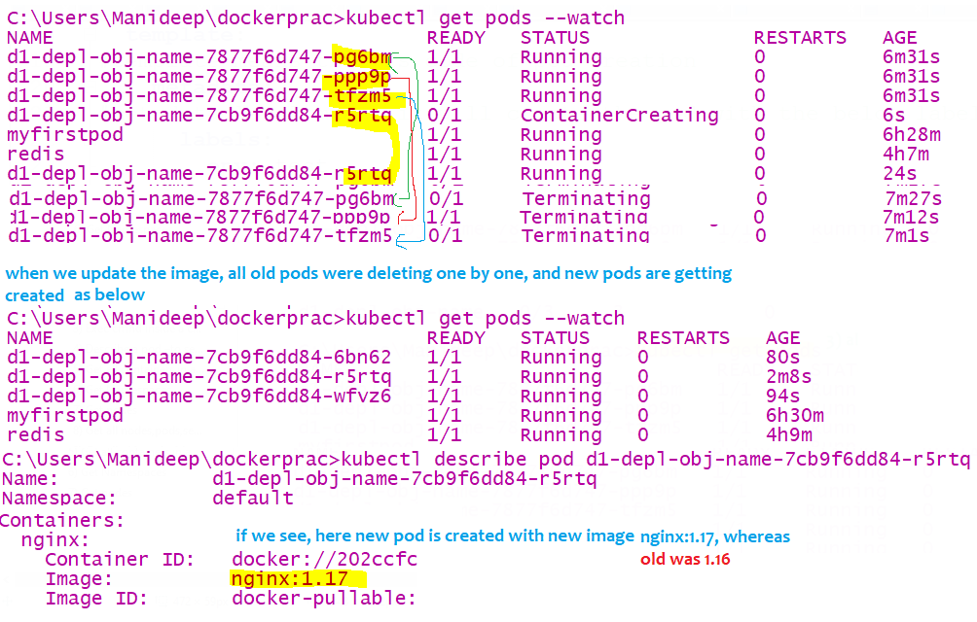

Rollout to older deployment
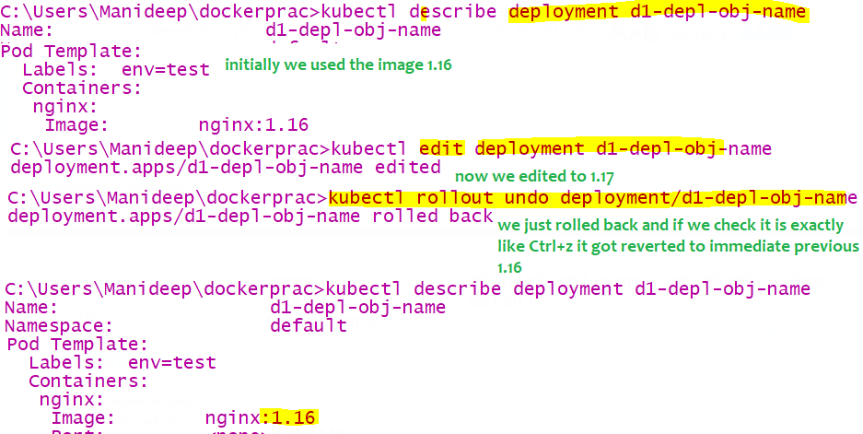

Example code:-
Refer attached file

observations
Observations notes
- When deployment object is running, if u update the port, old pods will be deleted (using deployment strategy:rollingupdate..or any other)one by one and new pods will be created , this is possible only using deployment object even when pod is running u can change port number,imagename,container name because with deployment object there is no downtime
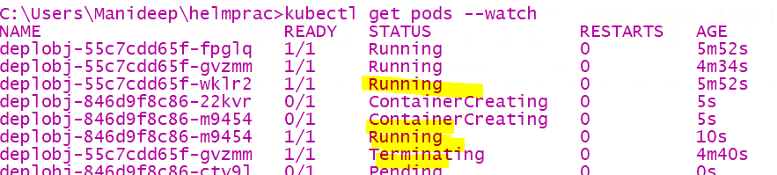
- Deployment object label can be anything, whereas u should tell the specifically tell to
replicaset to pick pod the certain label
Ex: if replicaset match label is realme, rs will select only those pods with realme label
Refer the attached file for understanding
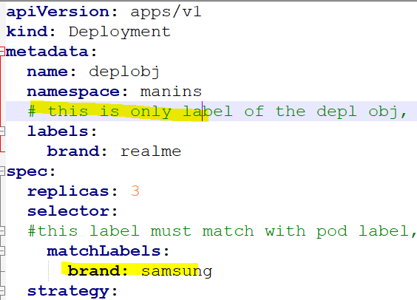

Daemon sets obj
Initially we have 3 nodes in a cluster and we have 1 pod on each node, later if we add the nodes to the cluster if u want to
create the pod in each and every node, then we should use daemon set object

Namespace object
It is an isolated space which is available across all the nodes in entire cluster (or across the nodes)
Namespace will span across the nodes
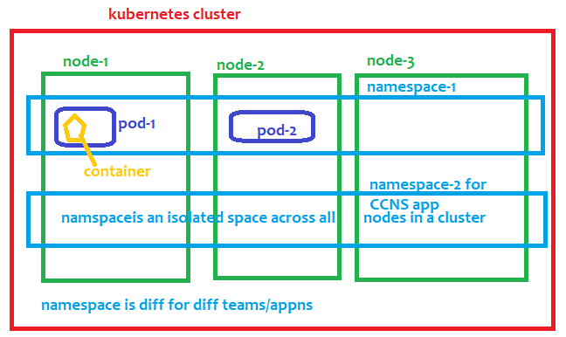
Namespace provides a mechanism for isolating group of resources or objects (pod,deployment,replicasets,secrets)
in same cluster
If 2 different teams application if u want to isolate then we will create a namespace (1 for each team)
- Name of the resources/objects-pod/Deployment should be unique within a namespace
Ex:- secrets will be stored in namespace level, if 2 apps are in same namespace, all will/can access those secrets
Some objects in the kubernetes are namespace scoped objects like POD,Deployment,
Whereas some objects will be deployed at cluster level
- Deployment object is a namespace scoped object,
Within the same name space, the name of the deployment must be distinct, and in another namespace the earlier names can be present.

Namespace should be different for each and every team, generally access will be given to the entire namespace
If both team apps are in same namespace, I have the ability to delete their pods.. if 2 teams have same namespace
1 team app may consume more CPU, RAM resources another team may not. .so to avoid conflicts better to have different namespace for all application
Some objects will reside in namespace-also called as namespace scoped objects-POD,Deployment
These 2 objects will reside in namespace
By default until u don’t set the namespace, u will be in default namespace
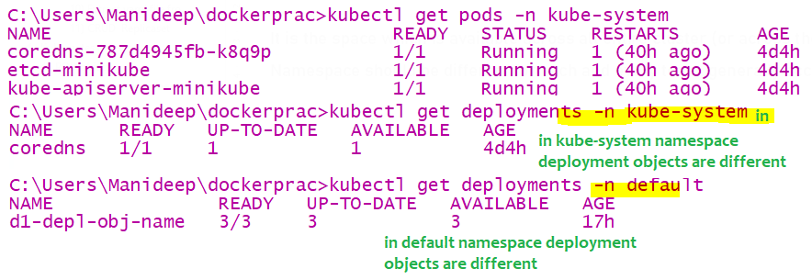
- CRUD Namespaces
To get all namespaces | kubectl get ns  kubectl get namespaces
Create a namespace | kubectl create namespace <name of the namespace>  kubectl create namespace maninamespace  kubectl create ns santons
To delete a namespace | kubectl delete ns <namespacename>
To get pods from diff namespace being in diff namespace | kubectl get pods -n <name of the namespace>  kubectl get pods -n kube-system
To get all objects from that namespace | kubectl get all -n <name of the namespace>  kubectl get all -n kube-system
To get pods from all namespces  This –A will work for all commands | kubectl get pods –A //means from all namespaces
In declarative approach if u want to create a object in particular ns, | Under metadata, add a field called namespace in YAML file, so that the file will be created in that namespace
To set a namespace to current context | kubectl config set-context –-current -–namespace=<ns name>  kubectl config set-context --current --namespace=maninamespace  kubectl config set-context --current --namespace=default
To know in which namespace u are in now | kubectl config get-contexts

Services Object-ingress
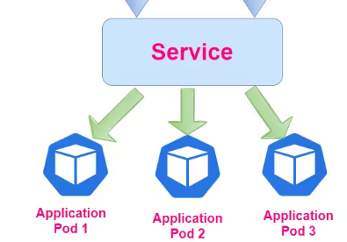
Here service object is a layer4 load balancer it will just dispatch the request to all the pods of same app (not diff apps) equally in round robin /some other fashion
This service object is only visible inside the cluster, external users outside from cluster cant access service objects
Service is an object in kubernetes representing the logical group of pods that perform the same task
In docker and kubernetes containers and pods are ephemeral they are very short lived,
Every pod will have ip address,
when they die and came back again, ip address of the pod changes, hence we can’t direct communicate with pods
So best way is talk to the service object, service object will talk to all the pods bec it maintains the registry , when a pod born and when a pod dies service obj will keep the track of all pods and their ip addresses
- This service obj provides a stable network endpoint to talk with pods
using subtypes “NodePort” …which ever subtype is applicable
type “kubectl get pods –o wide” to get pods names with their ip addresses
We should attach all the pods or (the replicaset/deployment obj) to service object using labels
So that if request comes to service object it will redirect to one of the pods, when we use service object,
we should use only service object name to communicate b/n 2 pods
service object is used to distribute the traffic among those pods,it will select the pods based on pod selector,
for every pod we have a label, so using the label of a pod the service object will select the pod
Service object is also called as internal load balancer
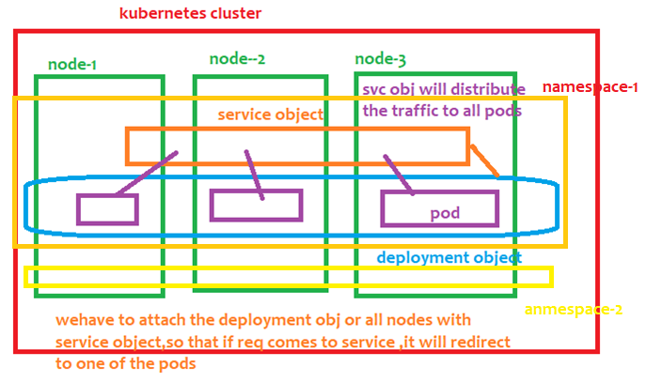
Service object is also a namespace scoped object,
After creating the service object ,if a pod joins with same label, then service object can distribute the
Traffic to new node also

- Generally 2 containers can communicate with each other using ip addresses,but in realtime we should not
Use ipaddress because they are ephemeral-temporary
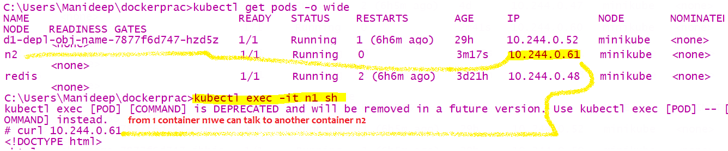
There are 3 types of service objects
- ClusterIP(it will generate an private ip for service object which is accessible only inside cluster)
- NodePort- not in production
- LoadBalancer
- Ingress

Source code for creating service object

To get all service object names | kubectl get services
To describe the service object-  If u want to know which pods its picking using pod selector-like u can access all pods using svc name | kubectl describe service awscluster  kubectl describe service <service-object-name>
To delete a service object | kubectl delete service <service-object-name>  kubectl delete service awscluster

- Service obj type-ClusterIP
If the service object type is clusterIp, then to that service object local ip will be provided,
Means that ip address is private and accessible only inside a cluster

2 pods communicating with service name
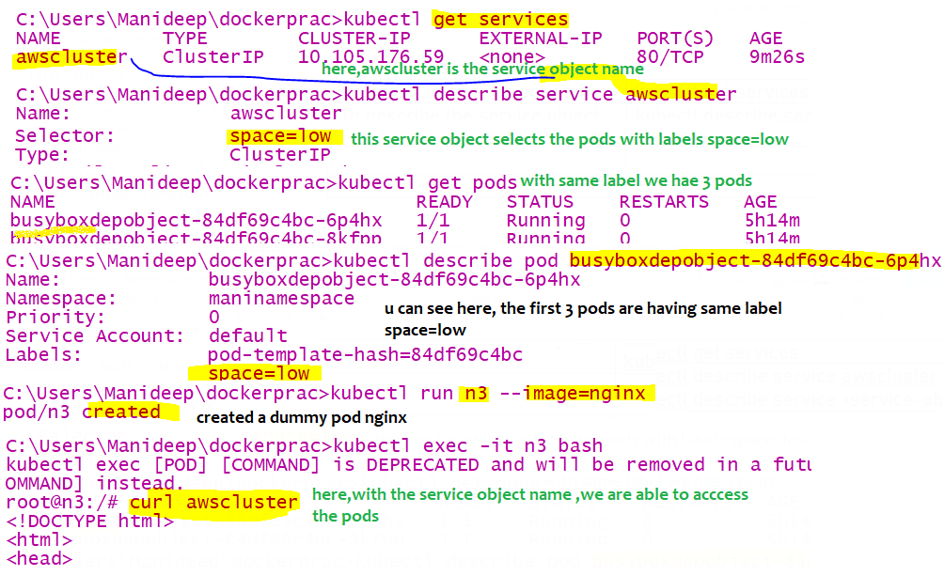

When ur are in namespace 1, and when u are trying to access service object present in different namespace
Then “curl 172.16.40.12” just ip address wont work, u have to access like
“servicename.namespace.basedomainName”
“awscluster.maninamespace.svc.cluster.local”
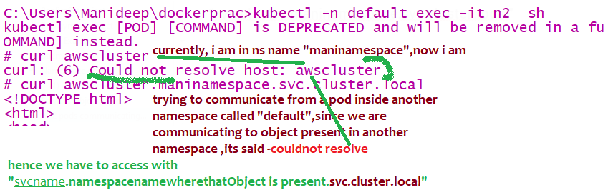

- Service Obj type- Node port
In kubernetes cluster, we have many nodes, node is nothing but a separate machine/separate virtual machine,
It is also having lot of ports like our computer, where each s/w runs on different port, tomcat runs on 8080,jboss runs on 8081..
When we have configured a service object of type “NodePort”, then if we call service object it will call that ports
Nodeport means=call to IpAddress of node+ port where service object is installed in the node machine(bec it have lot of ports)
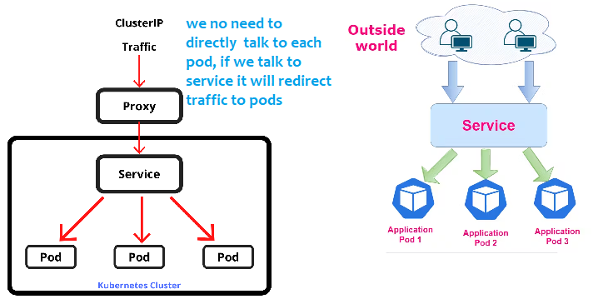
- What is the advantage of NodePort Service object ?
We can access the pod using node machines ipaddress+port of the node machine where svc obj is installed, (1 node is a separate vm, its has man ports open in that 1 port),we have to tell in node machine on which port this service is running
How to get nodes ip address
Kubectl get noes –o wide
With this we can access the pods using the ipaddress of the node and port of the service object
refer 6.serviceobject-Nodeport.yaml
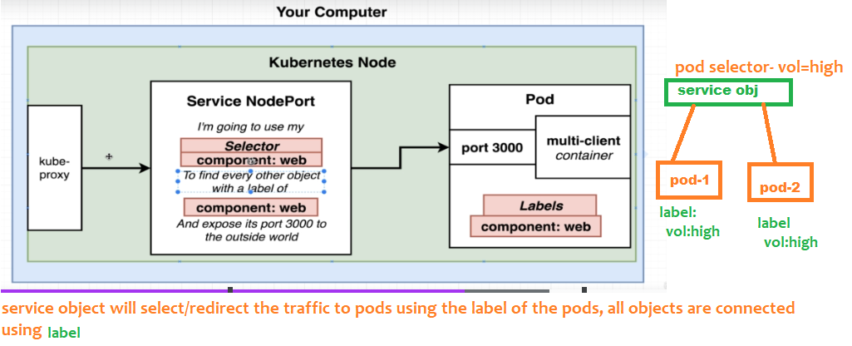
selector:
#selector is the most important, this service object main purpose is to redirect the traffic to the pods, this service object will select and send the traffic to the pods with the below label
brand: realme
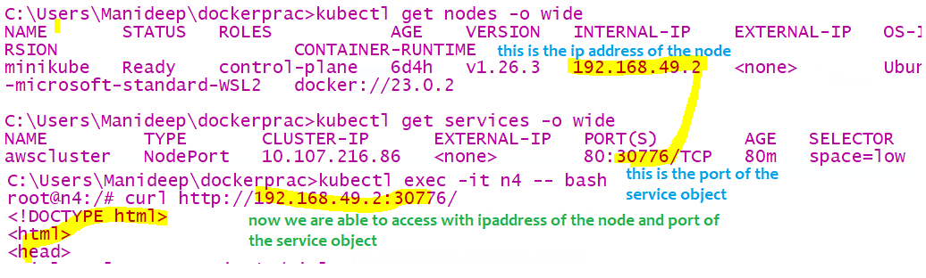
Here node port range will be from 30,000 to 32,767
Note:-
The container port matters a lot,container port means that is the port where the pod is already running

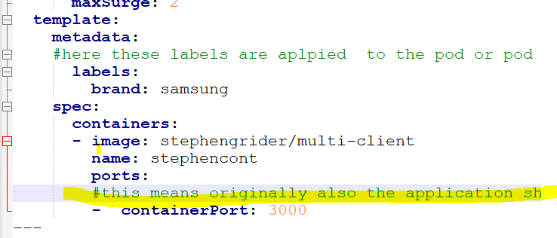

Example 2:-
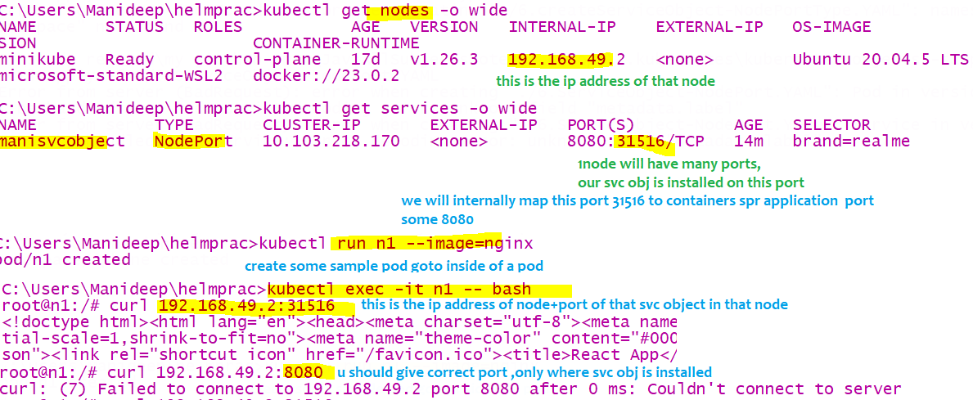

Ingress Gateway
https://www.youtube.com/watch?v=a4Kq6mX4Hr4
Layer 4 load balancer means = This is the load balancer for one application
that load balancer will redirect the incoming request to virtual machines of same app Here service object is a layer4 load balancer
Ex:- google will run that app in 1000 of servers, whereas request will always first be handled by front load balancer it will dispatch to one of back vms
Ingress Is a Layer 7 load balancer which is bit more powerful than layer 4, here this app is the load balancer for multiple applications
in this backend multiple diff apps will be there like Facebook, twitter, YouTube, so when request comes this LB will identify the url and it will redirect that request only to those particular set of vm’s
This layer 7 load balancer will identify the incoming URL and it will dispatch those request to those particular vm’s or that particular service object
In wells fargo we only 1 ingress controller for entire cluster, in that cluster many apps will be there,
- Request always reaches this ingress, later that ingress will route the request to correct apps by searching all apps present in cluster
Ingress is a layer7 load balancer & API level object that provides external access to service objects, kubernetes service object is a layer 4 load balancer, only this layer 7 LB can accept the outside traffic,
This will route external traffic to specific service objects which internally will call the pods (this ingress allows us to expose multiple services to the internet)
In ingress it has 2 components /objects – Ingress controller, ingress resource
Adv of this load balancer is cost- if u use the same load balancer for all app then cost will be decreased
For every cloud they have one specific ingress controller ex:- nginx people developed one own Ingress controller, aws have their own IC,
Kubernetes clusters will get external access to service objects by using ingress controllers and ingress resource
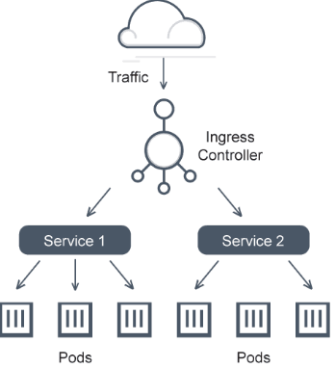 | Ingress is a namespace scoped object which enables external access to service object because of this these service object will be exposed to outside http  Ingress may provide load balancing (service obj is already load balancing and it will redirect the traffic to all pods )  apiVersion: networking.k8s.io/v1  kind: Ingress  metadata:  name: minimal-ingress  annotations:  nginx.ingress.kubernetes.io/rewrite-target: /  spec:  ingressClassName: nginx-example  rules:  - http:  paths:  - path: /testpath  pathType: Prefix  backend:  service:  name: test  port:  number: 80  This ingress obj will be created by TKGI team developer will not configure this for each and every project  Means externally from chrome we can access this ingress url

In kubernetes an Ingress is an API level object that define rules for routing external HTTP and HTTPs traffic to service objects within the cluster
Why ingress? If multiple apps are running in same cluster, taking one lb for each appln will be a costly, so here ingress will be the single load balancer for all apps
Deploy all ingress controller objects using the following command

//if u run this all pods will be created and objects like –pod,Deployment,job,replicasets,Ingress
most of the objects Will be created automatically in the ingress namespace
The main aim of ingress is to avoid creating multiple loadbalancers,only single load balancer,

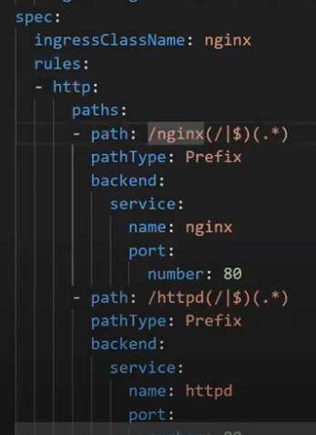 | 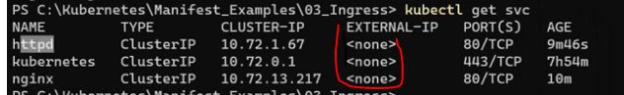  Here we have 2 service objects both are of clusterIP typed objects (all service doesn’t have any kind of external ip  Means these service objects are not visible outside)  Based on incoming request path, ingress will redirect the requests to respective service objects  - In above YAML file , a Service object of type load balancer will be created, when that object is  Created u will get the external url of load balancer  - Here if path is having nginx ingress is redirecting that request to nginx service object  - See nginx, httpd are 2 diff application here ingress is acting as a common load balancer for 2 applications  Based on request path, request will be redirect to any one of the service object  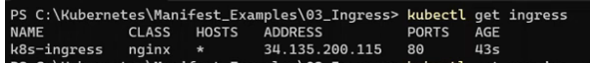  This is the url of ingress load balancer  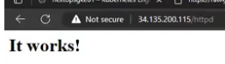  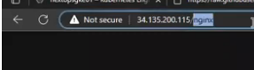  See here we are using same load balancer url to access both application, only based on path it is identifying and redirecting to specific service object
Get an ingress | kubectl get ingress
Describe ingress | kubectl describe ingress <ingress-name>

Service Mesh
Ex:- Istio (Istio is one example of service mesh there are many other service meshes available)
This is an extra layer of software you deploy along with your cluster which is used for gathering metrics and to monitor the traffic between those 2 pods

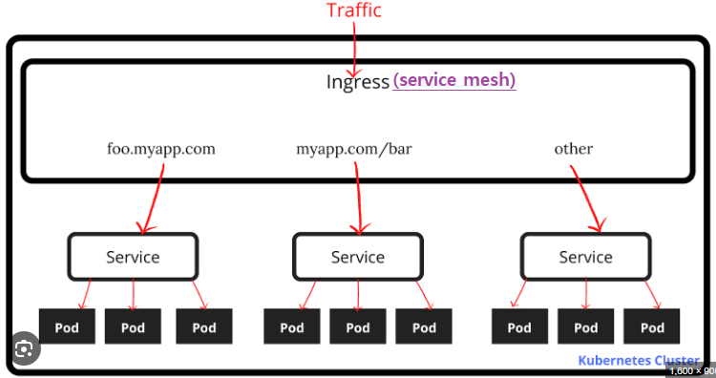 | 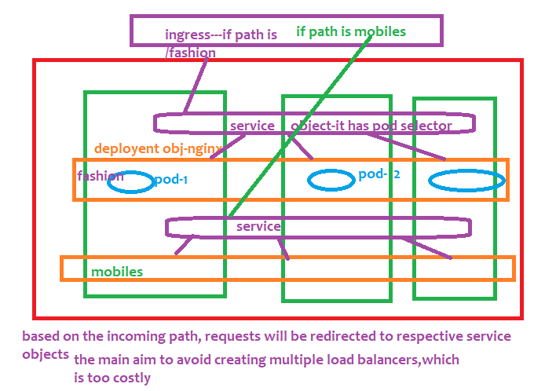

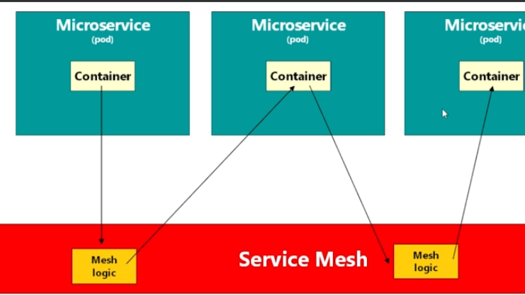
This service mesh is used for Telemetry (gathering metrics) this is something like filter which will be executed before and after calling target microservices
2 pods can communicate each other using service mesh advantage is service mesh will record time taken for inter communication between 2 microservices

Istio
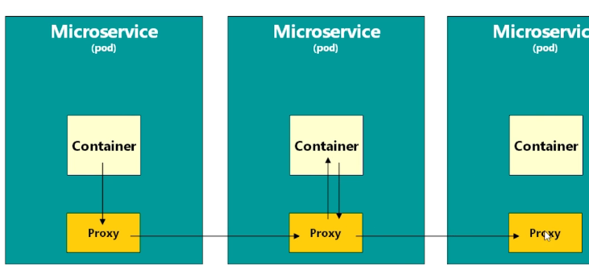  These proxies are collectively called “Data plane” in istio  In reality the proxy is nothing but a container (as 1 pod can have happily many containers) | In reality Istio install a proxy inside every pod so  when a container wants to talk to another container all calls will happen via proxy  now the proxy will calculate the time taken for interservice communication  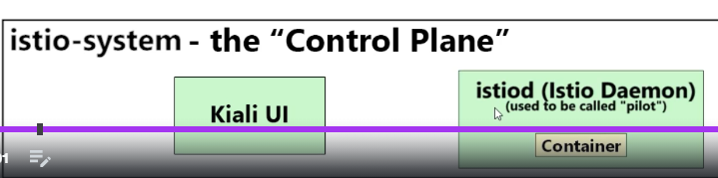  Here istiod Is a new separate pod which will gather all the metrics from the proxies  In the istio control plane there are totally 6 pods along with above 2 pods  All these pods will be separate namespace called “istio-system”

For istio, to gather the metrics, we should apply label to that namespace
Ex:- kubectl label namespace default Istio-injection=enabled
After labelling that namespace, istio will monitor the traffic between 2 pods

Side car container
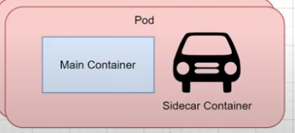 | Side car container is nothing but a helper container to main pod  Ex:- Like wife and husband, like life boats in a big ship  This sidecar container will share some of the works of main container  Note:- both containers will be in same pod  Can communicate via localhost

Passing env variables
1)using env element in containers
U can see all those env variables u can set with “kubectl describe pod <podname>”

configMap object
this object will reside in namespace(ns is nothing but isolated space present inside a cluster)
note;- in java configmap object will store all the key values, in react we will store entire file as a config map, means configmap object can store plain data as well as file data
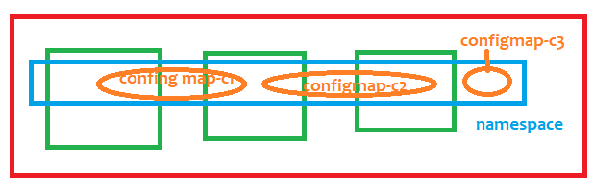
We can have multiple config-map objects present inside the namespace
If u run the config map using “kubectl apply -f ./9.createConfigMap.YAML” all the entries will set to config map object present which will be present in the namespace

To create a config map | kubectl apply -f ./9.createConfigMap.YAML
To see list of config maps | kubectl get configmap //from current namespace  kubectl get cm //from current namespace  kubectl get configmap –A //from all namespaces
Describe a config map | kubectl describe cm coredns -n kube-system  kubectl describe configmap <your config map object name>  kubectl describe configmap dbconfigmap  kubectl describe cm dbconfigmap

Create a configmap
If u create and execute that file, entire config map object will be stored in a namespace

Accessing a single value from that config map object present inside that namespace

spec:
containers:
- name: simple-web-app1
image: nginx:latest
ports:
- containerPort: 8080
env:
- name: anykey
valueFrom:
configMapKeyRef:
name: dbconfigmap
#this is the name of configmap object
key: dbpassword

Accessing all values from that config map object

- Accessing single and all values from configmap
env:
- name: databaseusername
valueFrom:
configMapKeyRef:
name: dbconfigmap
key: dbname
envFrom:
#we can get values from multiple maps,hence it is a list type,hence we used - symbol
- configMapRef:
name: dbconfigmap

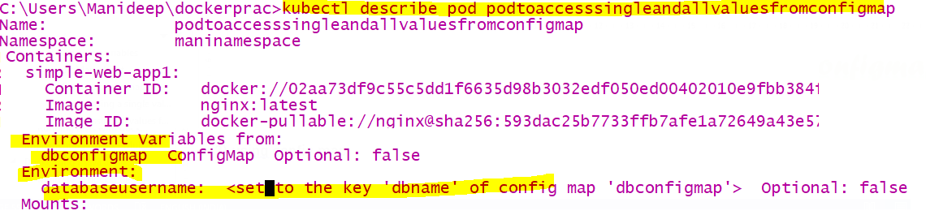

Secrets
Secrets is a namespace scoped object, Once u created secrets object, all those secrets will be stored at namespace
Only encrypted passwords will be allowed to place in the file
Get all secrets | kubectl get all secrets
Describe a secret  //even though u describe the secret u cannot see the password | kubectl describe secret dbsecrets  kubectl describe secret <secret name>

Fetching all values from a secret
Here we mentioned as secretREf-because we are referring to all key-value pairs
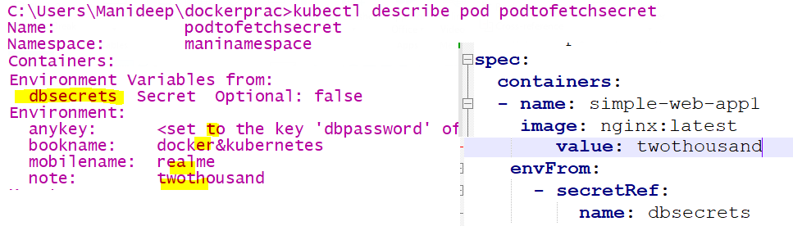

Fetching single value from a secret
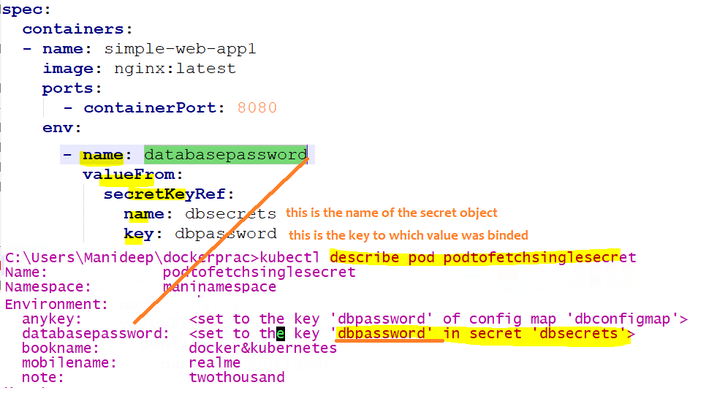
Here we mentioned as secretKeyRef -because we are referring to single key-value pair

How to pull image from private registry like jfrog/azure box
U have to create a secret Object with all those credentials of ur container registry like azure registry or jfrog
And u have to provide that secret object name in deployment.YAML file, while pulling the image we will mention the
Image name ,similarly we should mention secret object name, so that it will use that secret object credentials and pull that
Image from that private container registry
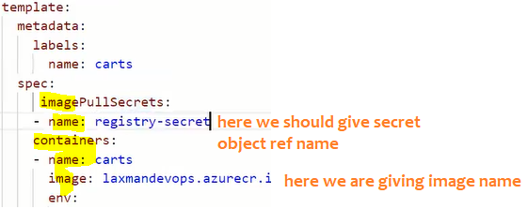

Role
Role is also a kubernetes namespace scoped object,

Example roles are
verbs: ["get", "list", "watch", "create", "update", "patch", "delete"]
we can map this role to any user or service account
to attach a role to any user, we cant simply give that role name to that user/service account, we should use
“RoleBinder” object
To get role | kubectl get roles
To delete a role | kubectl delete role <>roleobj-Name>  kubectl delete role roleobj

Always first 1) create a role 2) then create a service account
3) at last create a role binding object to bind/map role to that namespace

ServiceAccount
U should attach a role to a service account, instead of user credentials we will create a credentials which is going
To be used by application, ex:- In our code we wont keep our database username & password right, for application
We will create some credentials, those credentials will have some roles , like how we have some roles
For every service account, some roles will be mapped , we can use those service account credentials

To get all service account names | kubectl get serviceaccount
To delete particular service account name | kubectl delete serviceaccount <service-account-name>  kubectl delete serviceaccount svcaccobject
To get service accounts from all namespaces | kubectl get serviceaccount -A
Once a role is already mapped to a service account, then only that can do those role operations
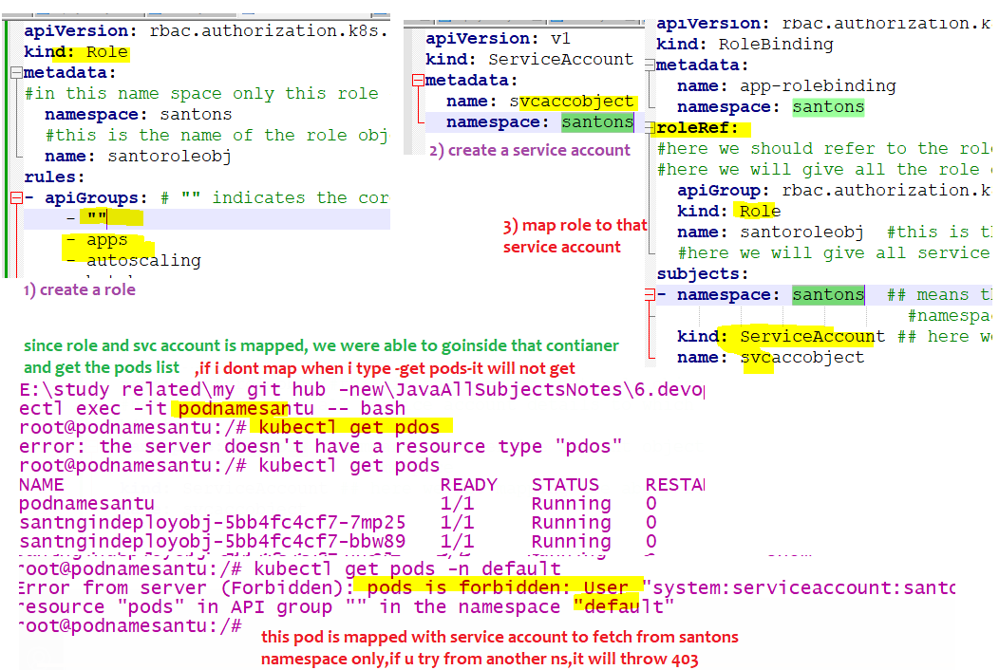

RoleBinding
This is also a kubernetes namespace scoped object
To get all rolebindings | kubectl get rolebindings
To delete a role binding | kubectl delete rolebinding <role binding object name>  kubectl delete rolebinding app-rolebinding

Example of role,RoleBinding,svcaccount
- Create a role object in ur namespace say “manins2” (here namespace name is manins2)
- Create a “ServiceAccount” object in your namespace
- Create a “RoleBinding” object used to bind above 2 objects
- 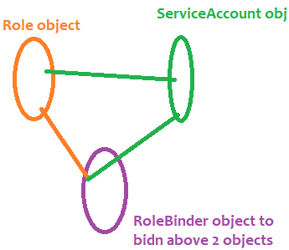
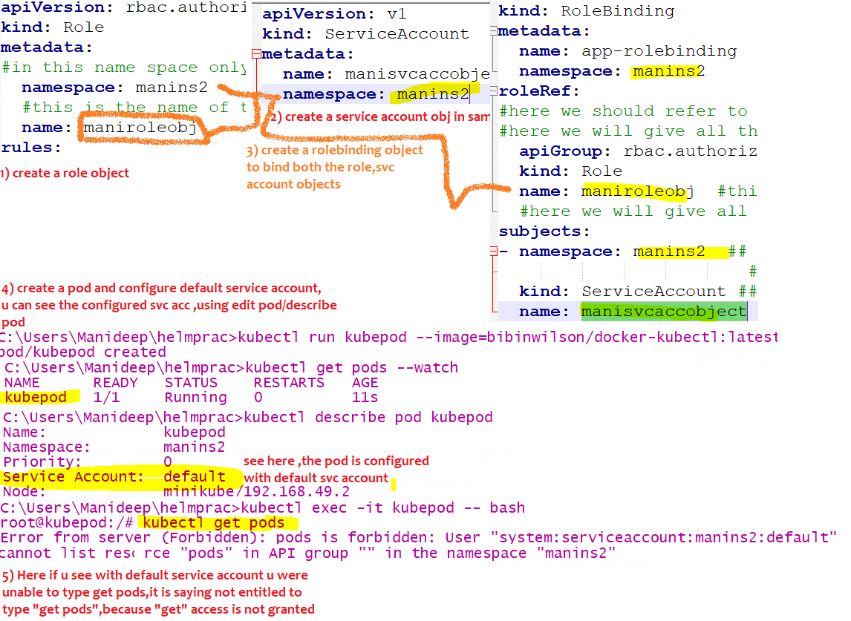
Now I edited the pod and changed to the serviceaccount which have all the access
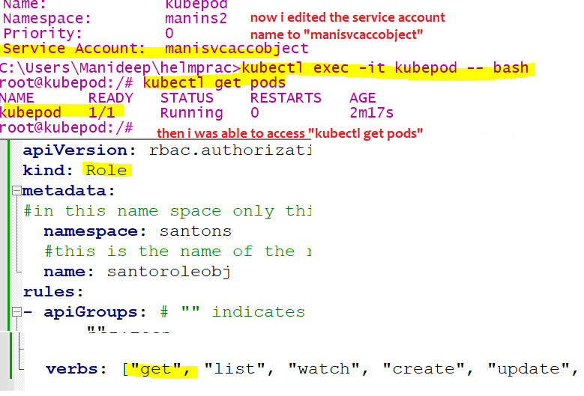
Lets re add the “delete entitlement” and see the status
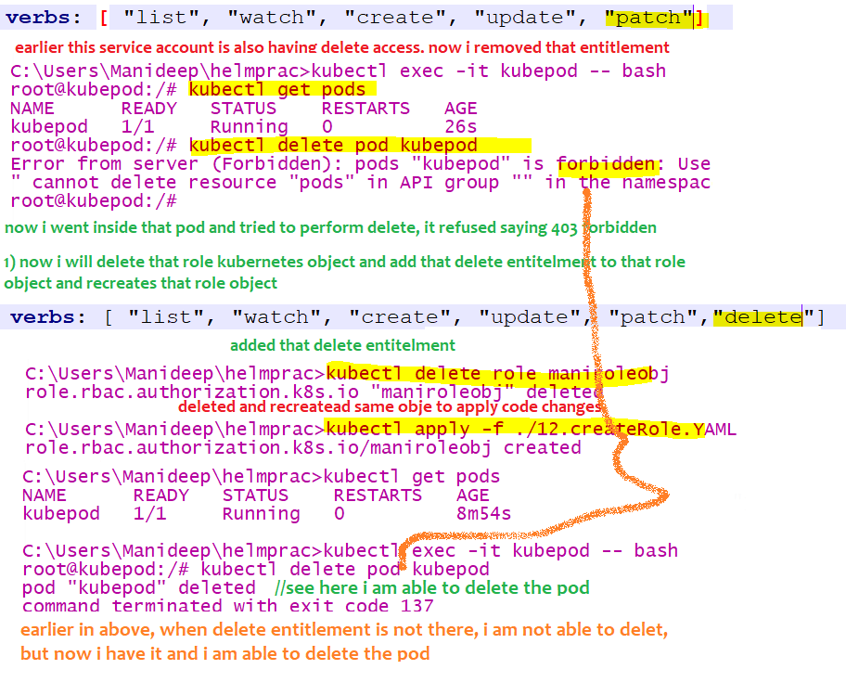

PKS
Pivotal kubernetes service- this means this is not just another kubernetes platform
This PKS is built on top of kubernetes with some additional features like roles, this PKS is built by keeping diff personas/roles/persons in mind
Ex:- “kubectl delete node <node-name>” in plain kubernetes any one can run this command, where as In PKS they have added roles like only platform engineers alone should run this command , with help of PKS this is possible like only platform eng can run this command
- PKS gives enterprise grade security
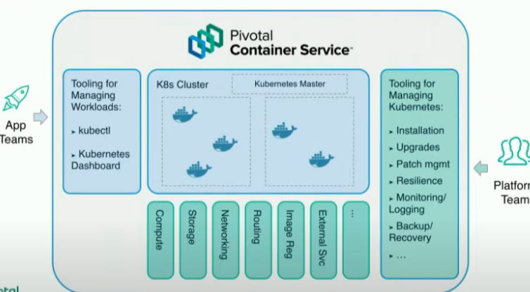
Each implementation of cluster api is specific to infrastructure
Cap A= cluster api for amazon
Cluster api == bosh infrastructure

Horizantalpodautoscaler
This is also a kubernetes object which is used to auto scale up/down the number of pods ,i.e., when load increases it will create new pods, when load decreases it will delete the existing pods, we can set minimum and maximum number, so based on that load , pods will be deleted and created automatically
Ex:- like in irctc 11:00 AM tatkal timings if load increases pods will be created automatically at that time and
Pods can be deleted automatically after load slowly decreases
How it works internally??
- First we have to install metric server, and we have to set the limits to our container or pod,
Check with this command “kubectl top nodes” or “kubectl top pods”
this will tell u whether metrics server is installed or not
- Then metric server will keep on sending the metrics to HorizontalPodAutoscaler object, then if existing mentioned
Cpu limits are getting crossed means, automatically additional pods will be created and deleted dynamically
- And we will link horizontal pod autoscaler with deployment object, else how does hpa know which obj to scale
In hpa.yaml file below, we linked hpa object with deployment object.

Steps to download the metrics server
- Git clone https://github.com/manideep-vv/Forked-k8s_metrics_server
- Go to deploy/1.8+ folder and execute all the yaml files using command “kubectl apply -f .”
- U can verify installation of metrics server using “kubectl top nodes”
- Now create a normal application with deployment object, all pods and deployment object should have a labels, then only HPA can select the deployment object and rescale it to have more replicas based on high load

To see list of available hpa | kubectl get hpa

Notes:
#namespace contains lot of deployment objects among them which deployment obj it should pick ,we should link hpa with Deployment object or some pod object, if u dont link how does the hpa object knows which Deploymentobj it should pick and scale,so remember to keep a selector so that hpa can pick that deployment object

Command to increase the load
kubectl run -i --tty load-generator --rm --image=busybox --restart=Never -- /bin/sh -c "while sleep 0.01; do wget -q -o- http://hpa-deployment-obj; done"

here “hpa-deployment-obj” is the name of the deployment object
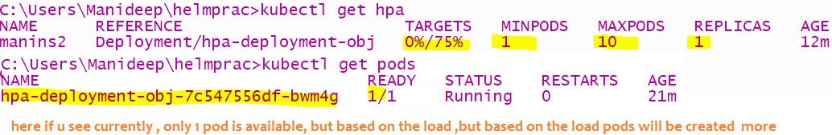
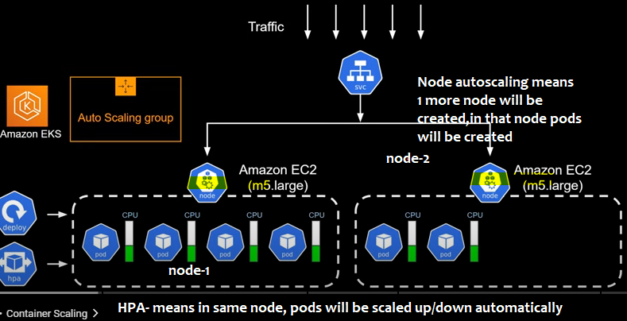

Volumes, persistent vol claims
NODE  │  ┌──────────┴──────────┐  │ │  POD A POD B  │  ┌─────┴─────┐  │ │  Container Container  │  └── emptyDir ← belongs to Pod  PVC ──────────────────→ PersistentVolume  ↑  survives Pod | Container filesystem  → tied to container  emptyDir  → tied to Pod  hostPath  → tied to Node  PVC/PV  → tied to persistent storage

A Volume defines storage for a Pod, volumeMounts exposes that volume inside a container, mountPath specifies where it appears, subPath allows mounting only a specific file or directory from the volume, and hostPath is a volume type that mounts a path from the Kubernetes node's filesystem.
One extra point worth remembering for your EKS + Helm interviews: ConfigMap/Secret volumes, PVC/EBS/EFS, and hostPath solve very different storage problems. Don't treat all Kubernetes volumes as persistent storage.

1. What is a Volume in Kubernetes?  A Volume is storage that can be attached to a Pod.  Containers are generally ephemeral. If a container restarts, files written inside the container's normal filesystem can disappear.  A Kubernetes Volume gives the container a place to store/access data outside its normal container filesystem.  Think:  Pod  │  ├── Container  │ └── /app  │  └── Volume  └── some storage  A volume is defined at the Pod level not at container level: bec if we define in container level after container restart that volume will vanish, hence we will define volumes at pod level  spec:  volumes:  - name: my-volume  emptyDir: {}  But defining a volume doesn't mean the container can see it yet.  That's where volumeMounts comes in. | since we created volumes in pod , if pod is deleted then volume in that pod also will be deleted, hence if we want long term storage we will store in persistent volu claims  2. Container restarts ≠ Pod restart  Suppose your Spring Boot container crashes:  Pod  └── Spring Boot container 💥  Kubernetes can restart the container:  Pod  └── Spring Boot container 🔄  The Pod itself wasn't deleted.  Therefore:  Pod identity  ↓  same Pod  ↓  container restarted  This is why emptyDir survives a container restart.  Example:  /app/data/file.txt  is stored in an emptyDir volume.  Container crashes:  Container dies  ↓  Container recreated  ↓  emptyDir still exists  ↓  file.txt still exists | 3. But what happens if the Pod itself is deleted?  This is different.  Suppose:  Pod A  └── Container  is deleted.  Kubernetes creates:  Pod B  └── Container  Pod B is a new Pod.  Now:  Pod A  ↓  deleted ❌  Pod B  ↓  created ✅  An emptyDir belonging to Pod A is also deleted:  Pod A  └── emptyDir  └── file.txt  Pod A deleted  ↓  emptyDir deleted  ↓  file.txt gone  That's why the definition says:  emptyDir survives container crashes/restarts, but is  deleted when the Pod is removed.

A Pod isn't normally "restarted" in the same way a container is. Kubernetes may restart containers inside a Pod. If the Pod itself needs to be replaced, Kubernetes deletes the old Pod and creates a new Pod. Pod-scoped storage such as emptyDir disappears with the old Pod, while persistent storage such as a PVC remains.
And one important correction to common terminology: "Pod restart" is often used casually, but Kubernetes doesn't have a simple restartPod operation. In practice, either a container is restarted, or the Pod is deleted/replaced by its controller (Deployment, StatefulSet, etc.).

Mounts
4. Then why doesn't PVC data disappear?  This is where PersistentVolume comes in.  Imagine:  Pod  │  │ PVC  ↓  PersistentVolume  │  ↓  EBS disk  Your Pod can disappear:  Pod A ❌  ↓  Pod B created  ↓  same PVC  ↓  same PersistentVolume  ↓  same data  So:  Pod lifecycle ≠ Persistent storage lifecycle  That's the whole purpose of persistent storage. | volume= some space  mounting= attach that USB drive or memory card to laptop  use creating mounts?  1st we will create volume[space] inside a pod not In container  then we will create volume mount= means creating a path  so that we can access that volume using that path  so if u don’t create mounts, u will not get path= means u cant store those files  2. What is volumeMounts?  volumeMounts tells Kubernetes:  "Mount/attach this Pod volume inside the container at this path."  Example:  spec:  volumes:  - name: my-volume  emptyDir: {}  containers:  - name: my-app  image: my-app:1.0  volumeMounts:  - name: my-volume  mountPath: /app/data  like when we attach a real USB stick to the laptop we will get some location[] , so that if we copy files to that location , it means we are keeping that files to that USB drive,  same like this when we attach a pod volume to a container we will get some location, if container uploads a file to the path it means we are uploading that file to that volume | if u don’t mount a volume then its waste right , bec that volume is present in pod , if u don’t mount /attach that vol to container u cant use it , so if u want to use vol , then u must mount that pod vol to container  Here:  Pod  │  └── Volume: my-volume  │  │ mounted into  ↓  Container  └── /app/data  Anything written to:  /app/data/file.txt  goes into the Kubernetes volume.  Important distinction  volumes:  means:  What storage do I want?  volumeMounts:  means:  Where should that storage appear inside my container?

Store Config map data in vol, sub path
3. Example with ConfigMap  This is where you'll see volumes very often.  volumes:  - name: config-volume  configMap:  name: my-config  Then:  volumeMounts:  - name: config-volume  mountPath: /app/config  Suppose ConfigMap contains:  data:  application.properties: |  server.port=8080  Inside the container you'll get:  /app/config/application.properties  So:  ConfigMap  ↓  Volume  ↓  volumeMount  ↓  /app/config/application.properties | subpath = Which part of the volume should I mount there?  4. What is subPath?  subPath is used when you don't want to mount the entire volume.and use this only when u want to mount only a part of the volume then use this sub path  Suppose your ConfigMap has:  data:  application.properties: |  server.port=8080  logback.xml: |  <configuration>...</configuration>  database.properties: |  db.url=...  Normally:  volumeMounts:  - name: config-volume  mountPath: /app/config  You get:  /app/config/  application.properties  logback.xml  database.properties | But suppose you only want:  application.properties  at:  /app/application.properties  Then:  volumeMounts:  - name: config-volume  mountPath: /app/application.properties  subPath: application.properties  Now:  ConfigMap volume  │  ├── application.properties ← selected  ├── logback.xml  └── database.properties  ↓  subPath  ↓  Container  /app/application.properties  Easy way to remember  mountPath:  Where should I mount the volume?  subPath:  Which part of the volume should I mount there?

Host path
5. What is hostPath?  hostPath means:  Use a directory/file from the Kubernetes node's filesystem.  Example:  volumes:  - name: host-volume  hostPath:  path: /var/log/myapp  type: DirectoryOrCreate  Then:  volumeMounts:  - name: host-volume  mountPath: /app/logs  Imagine your Kubernetes node has:  Node  └── /var/log/myapp  Your container sees:  Container  └── /app/logs  Both point to the same underlying location:  Node:  /var/log/myapp  ↑  │  ↓  Container:  /app/logs | 6. Why is hostPath dangerous in Kubernetes?  Because the storage belongs to the specific node.  Imagine:  Node 1  └── /var/log/myapp  ↑  Pod A  Then Pod A gets deleted and Kubernetes creates Pod B on Node 2:  Node 2  └── /var/log/myapp  Pod B sees Node 2's directory, not Node 1's data.  Therefore hostPath is generally not appropriate for application persistent data in a multi-node cluster.  It's more commonly used for things such as node-level access, specialized workloads, or certain DaemonSet use cases.  7. Volume vs volumeMount vs subPath vs hostPath  This is the most important comparison: | 5. hostPath is different again  With:  volumes:  - name: data  hostPath:  path: /data  the data belongs to the Node.  So:  Node 1  └── /data  └── file.txt  ↑  Pod A  If Pod A disappears and a new Pod is created on Node 1:  Node 1  └── /data  └── file.txt  ↑  Pod B  The file is still there.  But if Pod B gets scheduled on Node 2:  Node 2  └── /data  └── ???  it won't see Node 1's /data.  That's why hostPath is generally unsuitable for normal application persistent data in a multi-node EKS cluster.
  Concept | Meaning
  volume | Defines the storage
  volumeMounts | Mounts that storage into a container
  mountPath | Location inside the container
  subPath | Selects a particular directory/file from the volume
  hostPath | A volume type that uses storage directly from the Kubernetes node

8. Very important: hostPath is a type of Volume  This distinction is often confusing.  People sometimes think:  Volume  hostPath  are two completely different things.  Actually:  Volume  │  ├── emptyDir  ├── configMap  ├── secret  ├── hostPath  ├── persistentVolumeClaim  └── ...  hostPath is one type of volume.  For example:  volumes:  - name: my-volume  hostPath:  path: /data  Here:  my-volume = volume name  hostPath = volume type  /data = node filesystem path | 9. emptyDir vs hostPath  These are commonly compared.  emptyDir  volumes:  - name: data  emptyDir: {}  Kubernetes creates storage for the Pod on the node.  Pod  └── emptyDir  It survives container restart, but when the Pod is removed, the emptyDir data is deleted.  hostPath  volumes:  - name: data  hostPath:  path: /data  Uses an existing directory on the node:  Node  └── /data  The data isn't tied to the Pod's lifecycle in the same way, but it is tied to that particular node. | Kubernetes Pod  │  ┌────────┴────────┐  │ │  Volume Container  │ │  "What storage?" │  │ │  ┌───────┴──────┐ │  │ │ │  ConfigMap hostPath │  PVC emptyDir │  │ │  └────────────┐ │  ↓ ↓  volumeMounts  │  mountPath  │  /app/config  │  subPath  (optional)  │  specific file

Storage Data belongs to Container restart Pod deleted/recreated
Container filesystem Container ❌ Lost ❌ Lost
emptyDir Pod ✅ Survives ❌ Lost
hostPath Node ✅ Survives ✅ Survives if same node
PVC/PV Persistent storage ✅ Survives ✅ Survives

PVC persistent vol claims

Suppose you have:
Pod
│
└── PVC
↓
PersistentVolume
↓
EBS
Pod disappears:
Pod A ❌
↓
PVC ✅
↓
EBS data ✅
New Pod:
Pod B
↓
same PVC
↓
same EBS
↓
same data
That's the reason we use PVC for data that must survive Pod replacement.

